|  |  |
| --- | --- |
| TechNote |  |

# Downloading, installing, and activating Crystal Ball

## Licensing period August 2017 – August 2019

This TechNote describes how to download, install, and activate Crystal Ball as licensed by the Freeman School of Business. *Please note: This license of Crystal Ball is for use by students and faculty in the Freeman School of Business; use by others constitutes a violation of the license agreement.*

**You are three steps away from using Crystal Ball.**

1. Visit the Oracle web site at:

[http://edelivery.oracle.com](http://edelivery.oracle.com/)

**Create an Oracle Account as requested to make a profile with your own username and password (this is your own information and NOT the Username and Serial Number below).** Once you have created the profile, log in to the portal.

**Select Filter Program**

**In Product box type “Oracle Crystal Ball”** (There are many option for Crystal, see image below for product that needs to be selected.)

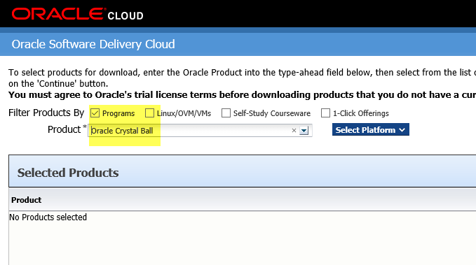

Choose “Oracle Crystal Ball” and the correct platform (32- or 64-bit) for your Windows machine. Almost all machines are running MS Office in 32 bit mode. So, even if your operating system is 64 bit, your version of MS Office could be 32 bit. (See below how to check platform for MS Office 2013 or 2016)

1. Install Crystal Ball. First extract the Crystal Ball files from the .zip file into a temporary directory, then run Setup.exe which will walk you through the installation**. You must exit Microsoft Excel® before you begin the installation.**

1. License Crystal Ball. -- Here is your Username and Serial Number: --

Product: Crystal Ball   
Username: Tulane2yr-SU2017@tulane.edu   
Serial Number: 9DC3C3E7-DA827013-A67C774E-EE6C2F3E

**There are two ways to activate your license:**

1. Click on the “Activate License” button at the bottom of the Welcome Screen that appears after you launch Crystal Ball. Enter your Username and Serial Number into the licensing dialog.

1. For Microsoft Excel 2000, 2002 (XP), and 2003, click on “Help > Crystal Ball > Licensing...” from the menu bar. (For Microsoft Excel 2007, click on the “Crystal Ball” tab, then “Resources > Licensing...”) Enter your Username and Serial Number into the licensing dialog.

If you are new to Crystal Ball or need technical support visit our Web site at:

<http://www.oracle.com/crystalball>

The Oracle Technology Network is also a great place to find resources:

<http://www.oracle.com/technology/index.html>

**Steps to check the version and platform type on Microsoft Office 2013/2016:**

1. Start a Microsoft Office program (Word, Excel, Outlook, etc.).
2. 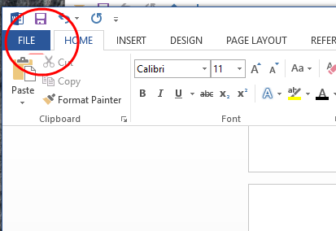Click the File tab in the ribbon.
3. 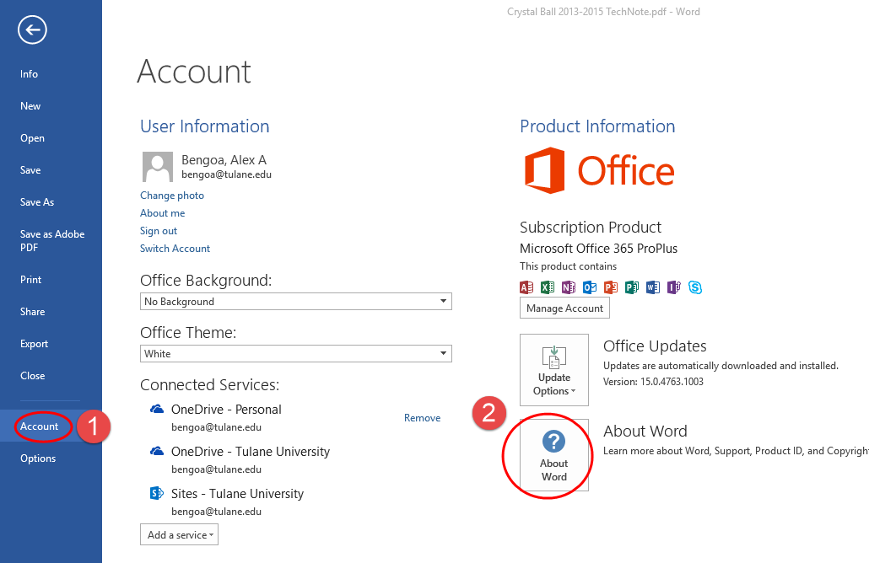Select Account in the left column. ...
4. Find the section called About Microsoft [Program Name] in the right column.

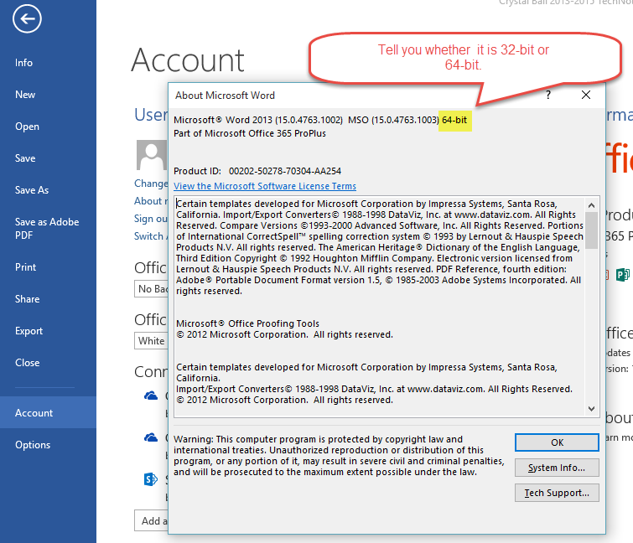

*Rev: jm 4/10/18*